Aloha “Hello Students,”

How has your summer been? Have you had an amazing time away from school? My summer has been very CRAZY!!!! My summer has been very exciting too. It started with a visit to Hawaii where I had an amazing time. The rest of the summer I have been to water parks and unpacking ALL my stuff at Oak Crest. I am reading lots of books and getting cool curriculum together for this year. This has definitely been a LEARNING experience.

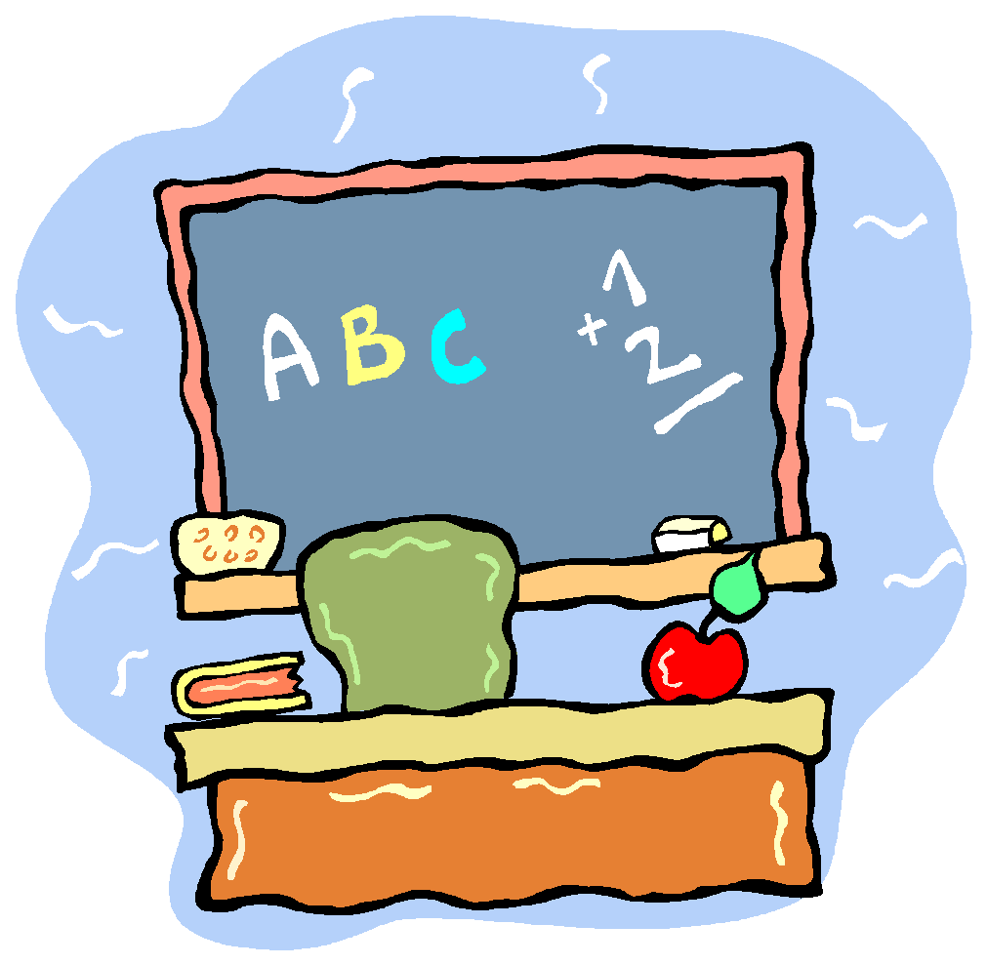
I am so excited about this year. We have many new students along with several from last year. You are going to be challenged in many different ways this year. I can’t wait to greet each of you on the first day back. Remember, you CAN do anything you put your mind to. BELIEVE IT!!!

Take care and get ready for a fun, creative, and exciting year.

Sincerely,

Mr. Peterson

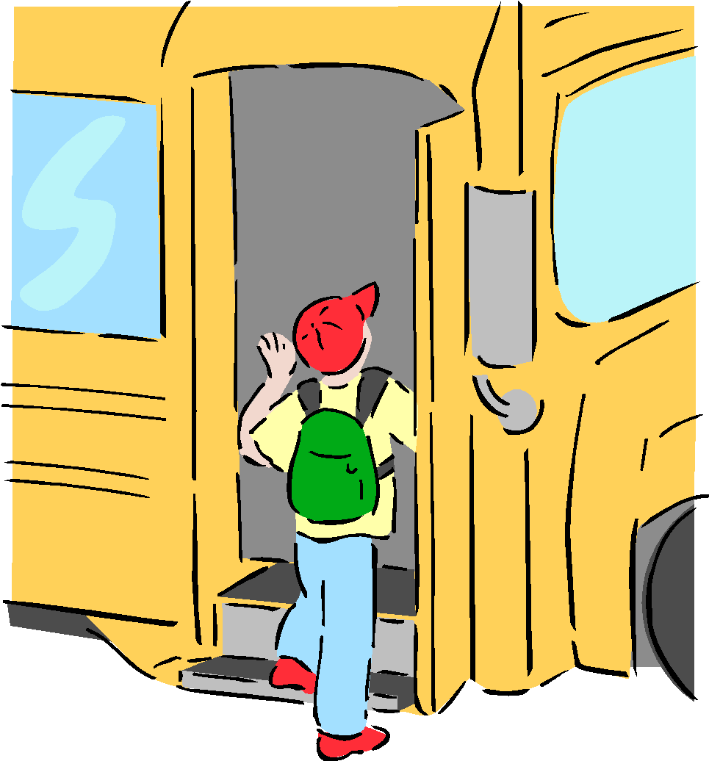
P.S. BE sure to get your supplies together—see school list or VISIT my website---kpetersonbpd3.weebly.com-
Classroom-drop down bar to---supply list

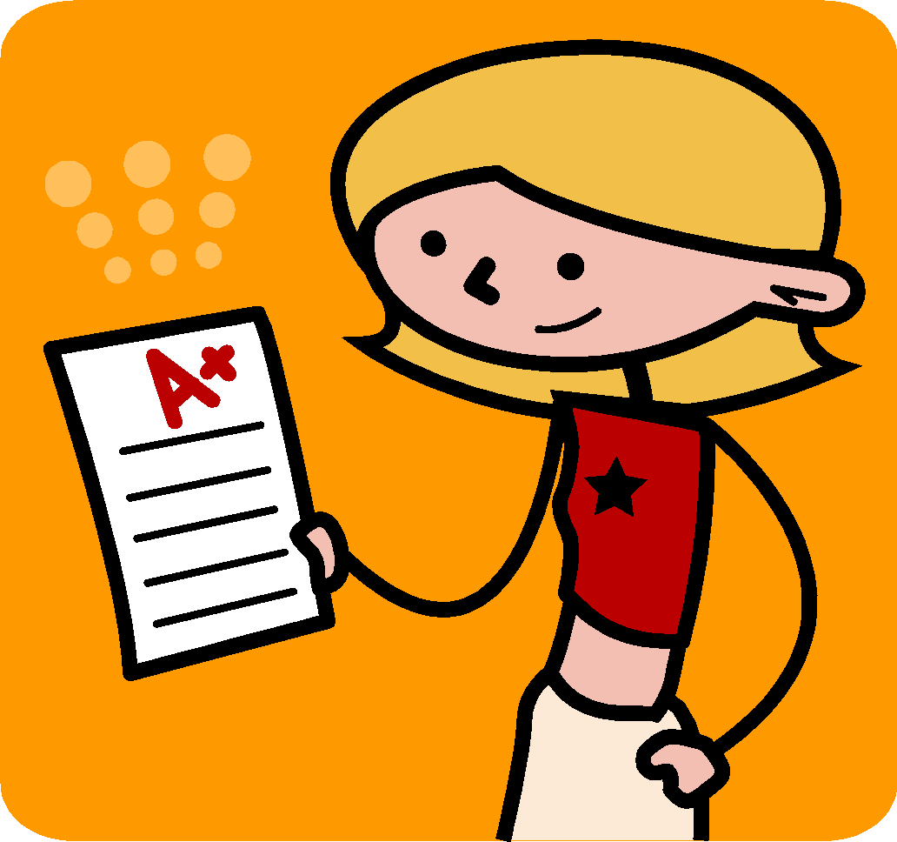
Mahalo – “Thank you”

